Ionic Bonding

Theory:
- Ionic Bonding occurs between a metal and a non-metal.
- Atoms react in order to achieve a full outer shell (the same electronic configuration as a noble gas)
- The metal atom gives away its outer shell electrons and forms a positive ion.
- The non-metal atom gains electrons to fill its outer shell and forms a negative ion.
- The formula of the compound depends on the number of each atom used.
- The actual ionic bond is the attraction of the ions for each other.

Questions:

- a) Showing only outer shell electrons complete the following dot and cross diagram to show how sodium bonds with chlorine:

Remember to include the charges on the ions
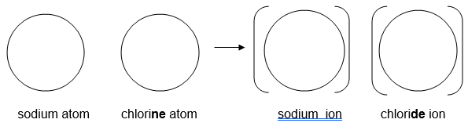

b) What is the formula of sodium chloride? ..............................................

c) The electronic configurations of sodium and chlorine are 2,8,1 and 2,8,7 respectively. What are the electronic configurations of their ions?

...........................................................................................................................

2. a) Complete the following dot and cross diagram to show what happens to the outer shell electrons when sodium joins to oxygen.
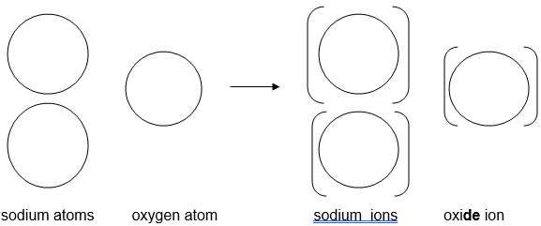

b) What is the formula of sodium oxide? ..............................................

2c) Using the diagram in part 2(a) to help you, describe clearly what happens when sodium bonds to oxygen. ALL of the following words should be used in your description: electrons, transfers, atom, ion, charge

.....................................................................................................................................................
.....................................................................................................................................................
.....................................................................................................................................................
.....................................................................................................................................................
.....................................................................................................................................................
....................................................................................................................................................

3. a) Complete the diagrams, showing the outer shell electrons in a calcium atom
and in a fluorine atom.
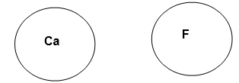

b) Draw a dot and cross diagram to show what happens to the outer shell electrons when calcium joins to fluorine. Remember to include square brackets and charges on the ions. (HINT: you may need to use more than one Ca or F atom)

c) What is the formula of calcium fluoride? ................................................

- Which of the following compounds would be ionic? Circle the correct answers:

NaCl CO₂ CaO AlF₃ CH₄

NCl₃ MgCl₂ H₂O K₂O

- Using only outer shell electrons, draw dot and cross diagrams to show the formation of the following compounds

a) potassium fluoride

b) aluminium chloride

- Using only outer shell electrons, draw dot and cross diagrams to show the formation of the following compounds

a) sodium nitride

b) aluminium oxide

